**Group 6 2ECE-B**

**REYES, John Emmanuel ECE 2112  
ZABALA, Jude Nico**

**MACHINE PROBLEM 5**

**CODE:**

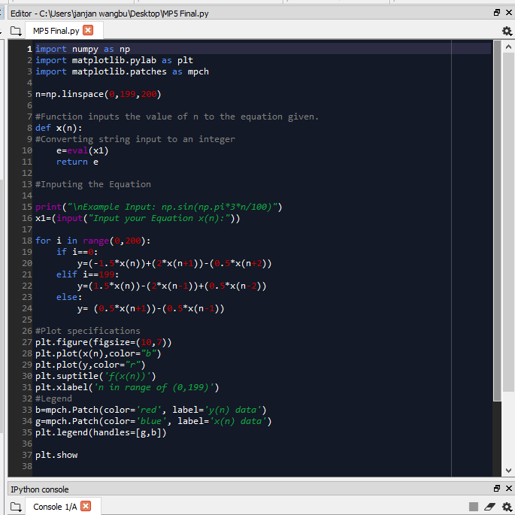

**SAMPLE OUTPUT:**

Trial 1: np.sin(np.pi*3*n/100)

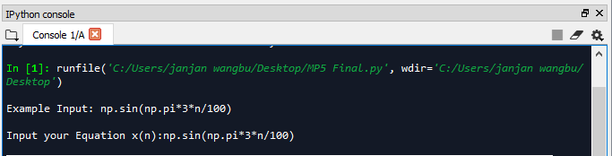

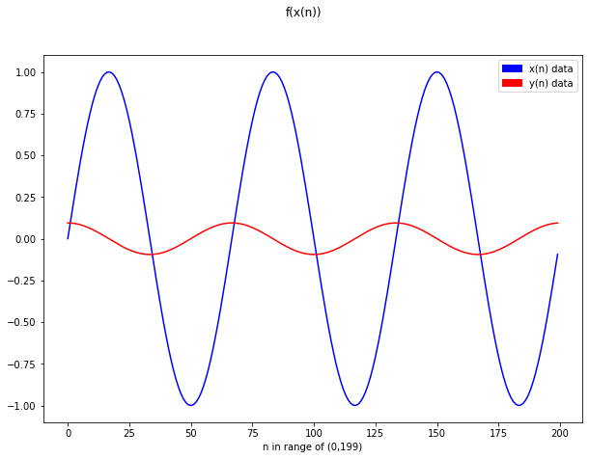

Trial 2: np.cos(np.pi*3*n/100)

